|  |  |  |
| --- | --- | --- |
|  | C:\Users\j.wright\AppData\Local\Microsoft\Windows\INetCache\Content.MSO\65C56D3D.tmp  North America |  |

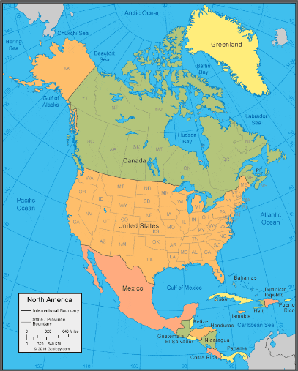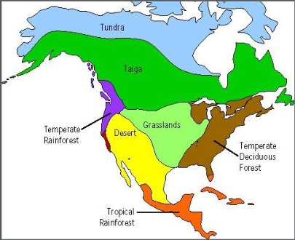

**THINGS TO TALK ABOUT AT HOME**

What do you think might affect population of different areas of the USA?

How do you think the population of North America might change in the next 100 years?

**DIAGRAM**

**Timeline of events/maps etc**

**KEY KNOWLEDGE**

* The USA is a country in the continent of North America and is bordered by the Pacific and Atlantic ocean.
* North America is made up of many countries, not just the USA, including Mexico, Canada and many smaller nations such as Cuba.
* A biome is a large area characterised by its vegetation, soil, climate, and wildlife.
* The Biomes in the USA are desert, tundra, forest, grassland, rainforest
* The UK is much smaller than the USA and is within one biome.
* Farming and agriculture in the USA is so diverse due to the size of the country and the variety of biomes.
* The USA has many physical and humans features including big cities (Vagas/New York Grand Canyon, Niagara Falls, Yosemite National park)
* Some areas of the USA are very densely populated, other areas are very sparsely populated.
* Over time, the population of the USA has grown massively with people migrating there for many different reasons.

**KEY VOCABULARY**

* **Agriculture**
* **biomes**
* **canyon**
* **urbanisation**
* **Climate**
* **Landscape**
* **Population**