Year 3

Rocks

**Knowledge Organiser**

**r**

VOCABULARY

**Magma**- molten rock that remains underground.

**Lava**- Molten rock that comes out of the ground is called lava.

**Sediment**- Natural solid material that is broken down by processes of weathering, erosion and transported by the action of wind, water or ice or by the force of gravity acting on it.

**Permeable**- Allows liquid to pass through.

**Impermeable**- Does not allow liquids to pass through.

**Durable**- withstand pressure, damage or hard wearing.

**Acidity**- the level of acid in substances.

The Rock Cycle.

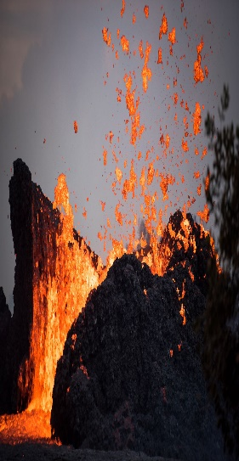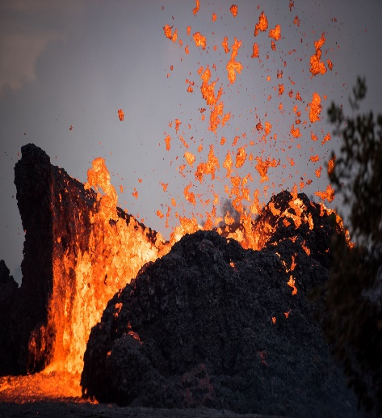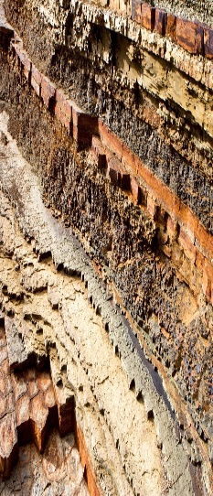nnh

METAMORPHIC ROCK

Rock that started out as igneous or sedimentary but changed due to being exposed to extreme heat or pressure.

Example: Marble, Quartzite, Slate.

**IGNEOUS ROCK**

Rock that has been formed from magma or lava.

Examples: obsidian, granite, basalt

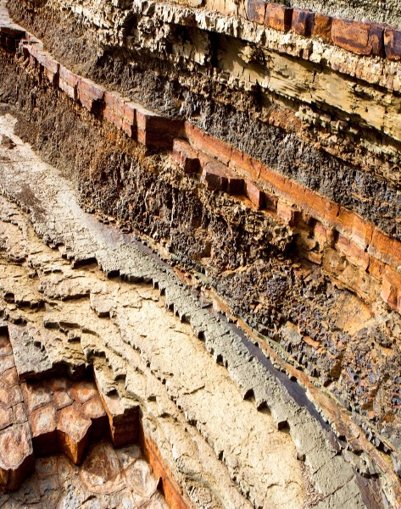

HUMAN_MADE ROCK

(Anthropic Rocks)

Rocks made or modified by humans. The Romans first invented concrete.

Example: Brick, Concrete, Coade Stone.

**SEDIMENTARY ROCK**

Rock that has been formed by layers of sediment being pressed down hard and sticking together. You will see layers in the rock.

Example: chalk, sandstone, limestone.



Year 3

Rocks

The Process of Fossilisation.

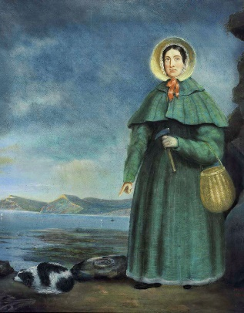

**Mary Anning (1799-1847)**

English fossil collector who became known around the world for finds she made in Jurassic marine fossil beds located in Lyme Regis. She correctly identified the ichthyosaur when she was 12 years old. She was known as ‘Mary Anning, The Fossil Finder’.

|  |  |
| --- | --- |
|  | An animal dies. It gets covered in sediment. After a while the animal will rot leaving behind only the bones (skeleton). |
|  | Layers of rock cover the skeleton. |
|  | Over thousands of years pressure forces the sedimentary layers together, turning them into sedimentary rock. Sediment enters the mould to make a cast fossil. |
|  | The water transports tiny pieces of impermeable rock, which are left inside the mould. Over time the whole skeleton or remains will become solid rock- called a cast |
|  | As erosion and weathering take place, eventually the fossil becomes exposed. Scientists called palaeontologists examine bones to find out about animals. |

Soil

Soil is the uppermost layer of the Earth. It is a mixture of different things:

-Minerals

-Air

-Water

-Organic matter (including living and dead plants and animals)

